MONGO TASK

1.Find all the information about each products

products> db.products.find({})

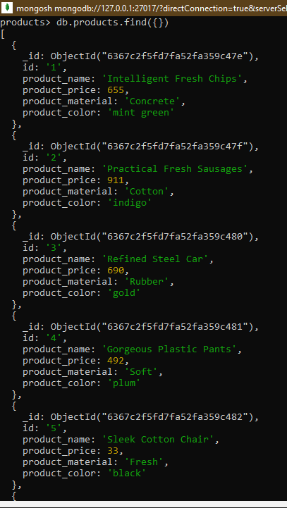

[

{

_id: ObjectId("6367c2f5fd7fa52fa359c47e"),

id: '1',

product_name: 'Intelligent Fresh Chips',

product_price: 655,

product_material: 'Concrete',

product_color: 'mint green'

},

{

_id: ObjectId("6367c2f5fd7fa52fa359c47f"),

id: '2',

product_name: 'Practical Fresh Sausages',

product_price: 911,

product_material: 'Cotton',

product_color: 'indigo'

},

{

_id: ObjectId("6367c2f5fd7fa52fa359c480"),

id: '3',

product_name: 'Refined Steel Car',

product_price: 690,

product_material: 'Rubber',

product_color: 'gold'

},

{

_id: ObjectId("6367c2f5fd7fa52fa359c481"),

id: '4',

product_name: 'Gorgeous Plastic Pants',

product_price: 492,

product_material: 'Soft',

product_color: 'plum'

},

{

_id: ObjectId("6367c2f5fd7fa52fa359c482"),

id: '5',

product_name: 'Sleek Cotton Chair',

product_price: 33,

product_material: 'Fresh',

product_color: 'black'

},

{

_id: ObjectId("6367c2f5fd7fa52fa359c483"),

id: '6',

product_name: 'Awesome Wooden Towels',

product_price: 474,

product_material: 'Plastic',

product_color: 'orange'

},

{

_id: ObjectId("6367c2f5fd7fa52fa359c484"),

id: '7',

product_name: 'Practical Soft Shoes',

product_price: 500,

product_material: 'Rubber',

product_color: 'pink'

},

{

_id: ObjectId("6367c2f5fd7fa52fa359c485"),

id: '8',

product_name: 'Incredible Steel Hat',

product_price: 78,

product_material: 'Rubber',

product_color: 'violet'

},

{

_id: ObjectId("6367c2f5fd7fa52fa359c486"),

id: '9',

product_name: 'Awesome Wooden Ball',

product_price: 28,

product_material: 'Soft',

product_color: 'azure'

},

{

_id: ObjectId("6367c2f5fd7fa52fa359c487"),

id: '10',

product_name: 'Generic Wooden Pizza',

product_price: 84,

product_material: 'Frozen',

product_color: 'indigo'

},

{

_id: ObjectId("6367c2f5fd7fa52fa359c488"),

id: '11',

product_name: 'Unbranded Wooden Cheese',

product_price: 26,

product_material: 'Soft',

product_color: 'black'

},

{

_id: ObjectId("6367c2f5fd7fa52fa359c489"),

id: '12',

product_name: 'Unbranded Plastic Salad',

product_price: 89,

product_material: 'Wooden',

product_color: 'pink'

},

{

_id: ObjectId("6367c2f5fd7fa52fa359c48a"),

id: '13',

product_name: 'Gorgeous Cotton Keyboard',

product_price: 37,

product_material: 'Concrete',

product_color: 'sky blue'

},

{

_id: ObjectId("6367c2f5fd7fa52fa359c48b"),

id: '14',

product_name: 'Incredible Steel Shirt',

product_price: 54,

product_material: 'Metal',

product_color: 'white'

},

{

_id: ObjectId("6367c2f5fd7fa52fa359c48c"),

id: '15',

product_name: 'Ergonomic Cotton Hat',

product_price: 43,

product_material: 'Rubber',

product_color: 'mint green'

},

{

_id: ObjectId("6367c2f5fd7fa52fa359c48d"),

id: '16',

product_name: 'Small Soft Chair',

product_price: 47,

product_material: 'Cotton',

product_color: 'teal'

},

{

_id: ObjectId("6367c2f5fd7fa52fa359c48e"),

id: '17',

product_name: 'Incredible Metal Car',

product_price: 36,

product_material: 'Fresh',

product_color: 'indigo'

},

{

_id: ObjectId("6367c2f5fd7fa52fa359c48f"),

id: '18',

product_name: 'Licensed Plastic Bacon',

product_price: 88,

product_material: 'Steel',

product_color: 'yellow'

},

{

_id: ObjectId("6367c2f5fd7fa52fa359c490"),

id: '19',

product_name: 'Intelligent Cotton Chips',

product_price: 46,

product_material: 'Soft',

product_color: 'azure'

},

{

_id: ObjectId("6367c2f5fd7fa52fa359c491"),

id: '20',

product_name: 'Handcrafted Wooden Bacon',

product_price: 36,

product_material: 'Concrete',

product_color: 'lime'

}

]

Type "it" for more

products> it

[

{

_id: ObjectId("6367c2f5fd7fa52fa359c492"),

id: '21',

product_name: 'Unbranded Granite Chicken',

product_price: 90,

product_material: 'Metal',

product_color: 'gold'

},

{

_id: ObjectId("6367c2f5fd7fa52fa359c493"),

id: '22',

product_name: 'Ergonomic Soft Hat',

product_price: 99,

product_material: 'Rubber',

product_color: 'black'

},

{

_id: ObjectId("6367c2f5fd7fa52fa359c494"),

id: '23',

product_name: 'Intelligent Steel Pizza',

product_price: 95,

product_material: 'Cotton',

product_color: 'azure'

},

{

_id: ObjectId("6367c2f5fd7fa52fa359c495"),

id: '24',

product_name: 'Tasty Rubber Cheese',

product_price: 47,

product_material: 'Frozen',

product_color: 'orchid'

},

{

_id: ObjectId("6367c2f5fd7fa52fa359c496"),

id: '25',

product_name: 'Licensed Steel Car',

product_price: 20,

product_material: 'Cotton',

product_color: 'indigo'

}

]

2.Find the product price which are between 400 to 800

db.products.find({product_price :{$gt:400,$lt:800}})

[

{

_id: ObjectId("6367c2f5fd7fa52fa359c47e"),

id: '1',

product_name: 'Intelligent Fresh Chips',

product_price: 655,

product_material: 'Concrete',

product_color: 'mint green'

},

{

_id: ObjectId("6367c2f5fd7fa52fa359c480"),

id: '3',

product_name: 'Refined Steel Car',

product_price: 690,

product_material: 'Rubber',

product_color: 'gold'

},

{

_id: ObjectId("6367c2f5fd7fa52fa359c481"),

id: '4',

product_name: 'Gorgeous Plastic Pants',

product_price: 492,

product_material: 'Soft',

product_color: 'plum'

},

{

_id: ObjectId("6367c2f5fd7fa52fa359c483"),

id: '6',

product_name: 'Awesome Wooden Towels',

product_price: 474,

product_material: 'Plastic',

product_color: 'orange'

},

{

_id: ObjectId("6367c2f5fd7fa52fa359c484"),

id: '7',

product_name: 'Practical Soft Shoes',

product_price: 500,

product_material: 'Rubber',

product_color: 'pink'

}]

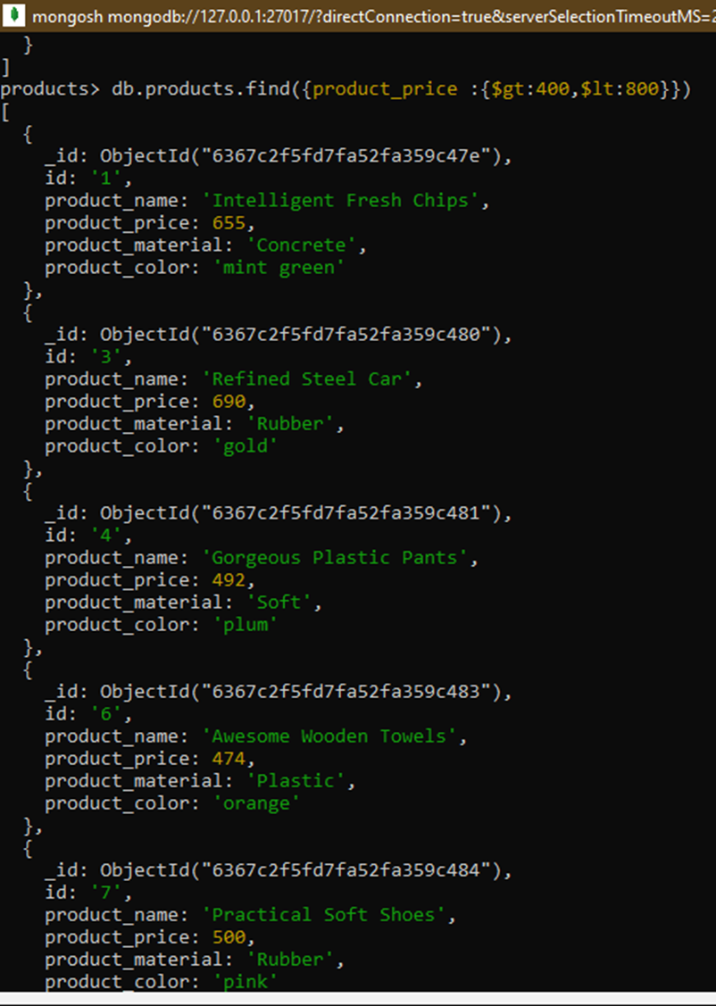

3.Find the product price which are not between 400 to 600

db.products.find({"product_price":{ $not:{$gt:400, $lt:600} } })

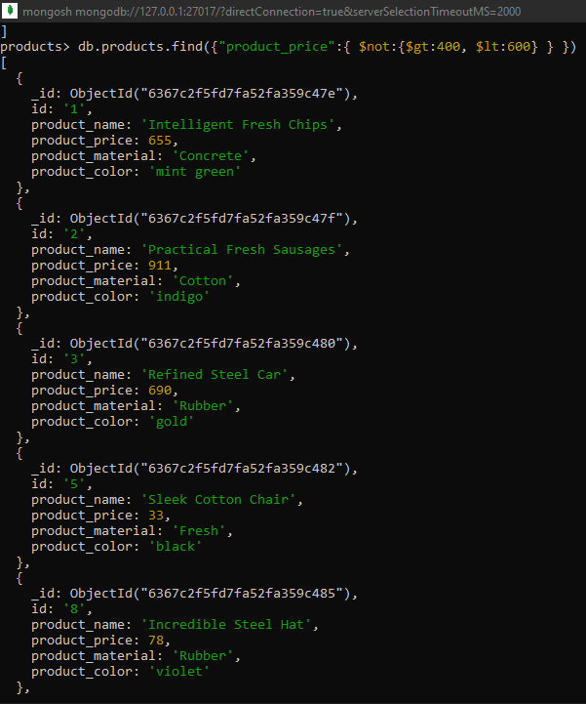

[

{

_id: ObjectId("6367c2f5fd7fa52fa359c47e"),

id: '1',

product_name: 'Intelligent Fresh Chips',

product_price: 655,

product_material: 'Concrete',

product_color: 'mint green'

},

{

_id: ObjectId("6367c2f5fd7fa52fa359c47f"),

id: '2',

product_name: 'Practical Fresh Sausages',

product_price: 911,

product_material: 'Cotton',

product_color: 'indigo'

},

{

_id: ObjectId("6367c2f5fd7fa52fa359c480"),

id: '3',

product_name: 'Refined Steel Car',

product_price: 690,

product_material: 'Rubber',

product_color: 'gold'

},

{

_id: ObjectId("6367c2f5fd7fa52fa359c482"),

id: '5',

product_name: 'Sleek Cotton Chair',

product_price: 33,

product_material: 'Fresh',

product_color: 'black'

},

{

_id: ObjectId("6367c2f5fd7fa52fa359c485"),

id: '8',

product_name: 'Incredible Steel Hat',

product_price: 78,

product_material: 'Rubber',

product_color: 'violet'

},

{

_id: ObjectId("6367c2f5fd7fa52fa359c486"),

id: '9',

product_name: 'Awesome Wooden Ball',

product_price: 28,

product_material: 'Soft',

product_color: 'azure'

},

{

_id: ObjectId("6367c2f5fd7fa52fa359c487"),

id: '10',

product_name: 'Generic Wooden Pizza',

product_price: 84,

product_material: 'Frozen',

product_color: 'indigo'

},

{

_id: ObjectId("6367c2f5fd7fa52fa359c488"),

id: '11',

product_name: 'Unbranded Wooden Cheese',

product_price: 26,

product_material: 'Soft',

product_color: 'black'

},

{

_id: ObjectId("6367c2f5fd7fa52fa359c489"),

id: '12',

product_name: 'Unbranded Plastic Salad',

product_price: 89,

product_material: 'Wooden',

product_color: 'pink'

},

{

_id: ObjectId("6367c2f5fd7fa52fa359c48a"),

id: '13',

product_name: 'Gorgeous Cotton Keyboard',

product_price: 37,

product_material: 'Concrete',

product_color: 'sky blue'

},

{

_id: ObjectId("6367c2f5fd7fa52fa359c48b"),

id: '14',

product_name: 'Incredible Steel Shirt',

product_price: 54,

product_material: 'Metal',

product_color: 'white'

},

{

_id: ObjectId("6367c2f5fd7fa52fa359c48c"),

id: '15',

product_name: 'Ergonomic Cotton Hat',

product_price: 43,

product_material: 'Rubber',

product_color: 'mint green'

},

{

_id: ObjectId("6367c2f5fd7fa52fa359c48d"),

id: '16',

product_name: 'Small Soft Chair',

product_price: 47,

product_material: 'Cotton',

product_color: 'teal'

},

{

_id: ObjectId("6367c2f5fd7fa52fa359c48e"),

id: '17',

product_name: 'Incredible Metal Car',

product_price: 36,

product_material: 'Fresh',

product_color: 'indigo'

},

{

_id: ObjectId("6367c2f5fd7fa52fa359c48f"),

id: '18',

product_name: 'Licensed Plastic Bacon',

product_price: 88,

product_material: 'Steel',

product_color: 'yellow'

},

{

_id: ObjectId("6367c2f5fd7fa52fa359c490"),

id: '19',

product_name: 'Intelligent Cotton Chips',

product_price: 46,

product_material: 'Soft',

product_color: 'azure'

},

{

_id: ObjectId("6367c2f5fd7fa52fa359c491"),

id: '20',

product_name: 'Handcrafted Wooden Bacon',

product_price: 36,

product_material: 'Concrete',

product_color: 'lime'

},

{

_id: ObjectId("6367c2f5fd7fa52fa359c492"),

id: '21',

product_name: 'Unbranded Granite Chicken',

product_price: 90,

product_material: 'Metal',

product_color: 'gold'

},

{

_id: ObjectId("6367c2f5fd7fa52fa359c493"),

id: '22',

product_name: 'Ergonomic Soft Hat',

product_price: 99,

product_material: 'Rubber',

product_color: 'black'

},

{

_id: ObjectId("6367c2f5fd7fa52fa359c494"),

id: '23',

product_name: 'Intelligent Steel Pizza',

product_price: 95,

product_material: 'Cotton',

product_color: 'azure'

}

]

Type "it" for more

products> it

[

{

_id: ObjectId("6367c2f5fd7fa52fa359c495"),

id: '24',

product_name: 'Tasty Rubber Cheese',

product_price: 47,

product_material: 'Frozen',

product_color: 'orchid'

},

{

_id: ObjectId("6367c2f5fd7fa52fa359c496"),

id: '25',

product_name: 'Licensed Steel Car',

product_price: 20,

product_material: 'Cotton',

product_color: 'indigo'

}

]

4.List the four product which are greater than 500 in price

db.products.find({product_price : {$gt :500}}).limit(4)

[

{

_id: ObjectId("6367c2f5fd7fa52fa359c47e"),

id: '1',

product_name: 'Intelligent Fresh Chips',

product_price: 655,

product_material: 'Concrete',

product_color: 'mint green'

},

{

_id: ObjectId("6367c2f5fd7fa52fa359c47f"),

id: '2',

product_name: 'Practical Fresh Sausages',

product_price: 911,

product_material: 'Cotton',

product_color: 'indigo'

},

{

_id: ObjectId("6367c2f5fd7fa52fa359c480"),

id: '3',

product_name: 'Refined Steel Car',

product_price: 690,

product_material: 'Rubber',

product_color: 'gold'

}

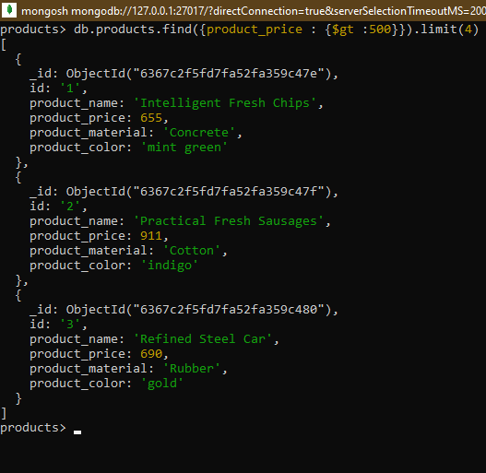

5.Find the product name and product material of each products

db.products.find({},{product_name:1,product_material:1,_id:0})

[

{

product_name: 'Intelligent Fresh Chips',

product_material: 'Concrete'

},

{

product_name: 'Practical Fresh Sausages',

product_material: 'Cotton'

},

{ product_name: 'Refined Steel Car', product_material: 'Rubber' },

{ product_name: 'Gorgeous Plastic Pants', product_material: 'Soft' },

{ product_name: 'Sleek Cotton Chair', product_material: 'Fresh' },

{product_name: 'Awesome Wooden Towels',product_material: 'Plastic'},

{ product_name: 'Practical Soft Shoes', product_material: 'Rubber' },

{ product_name: 'Incredible Steel Hat', product_material: 'Rubber' },

{ product_name: 'Awesome Wooden Ball', product_material: 'Soft' },

{ product_name: 'Generic Wooden Pizza', product_material: 'Frozen' },

{ product_name: 'Unbranded Wooden Cheese', product_material: 'Soft' },

{ product_name: 'Unbranded Plastic Salad', product_material: 'Wooden'},

{ product_name: 'Gorgeous Cotton Keyboard',product_material: 'Concrete'},

{ product_name: 'Incredible Steel Shirt', product_material: 'Metal' },

{ product_name: 'Ergonomic Cotton Hat', product_material: 'Rubber' },

{ product_name: 'Small Soft Chair', product_material: 'Cotton' },

{ product_name: 'Incredible Metal Car', product_material: 'Fresh' },

{ product_name: 'Licensed Plastic Bacon', product_material: 'Steel' },

{ product_name: 'Intelligent Cotton Chips', product_material: 'Soft' },

{ product_name: 'Handcrafted Wooden Bacon', product_material: 'Concrete' }

]

Type "it" for more

products> it

[

{ product_name: 'Unbranded Granite Chicken', product_material: 'Metal' },

{ product_name: 'Ergonomic Soft Hat', product_material: 'Rubber' },

{ product_name: 'Intelligent Steel Pizza', product_material: 'Cotton'},

{ product_name: 'Tasty Rubber Cheese', product_material: 'Frozen' },

{ product_name: 'Licensed Steel Car', product_material: 'Cotton' }

]

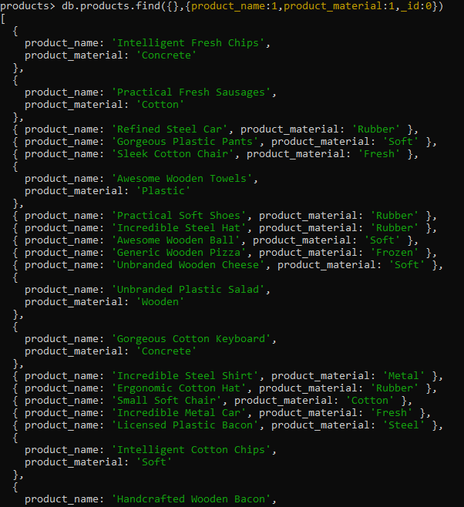

6.Find the product with a row id of 10.

db.products.find({id:"10"})

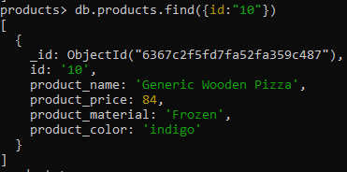

[

{

_id: ObjectId("6367c2f5fd7fa52fa359c487"),

id: '10',

product_name: 'Generic Wooden Pizza',

product_price: 84,

product_material: 'Frozen',

product_color: 'indigo'

}

]

7.Find all products which contain the value of soft in product material

db.products.find ({"product_material" :/soft/i})

NOTE: i here denotes caseinsensitive

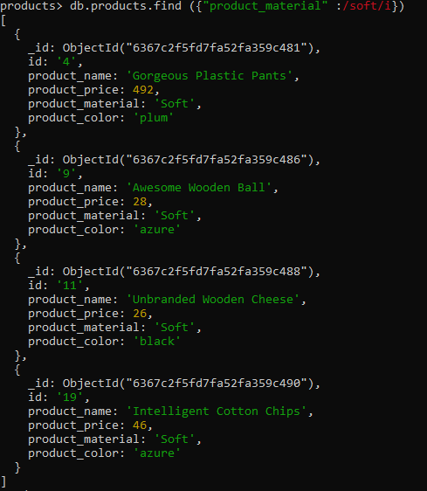

[

{

_id: ObjectId("6367c2f5fd7fa52fa359c481"),

id: '4',

product_name: 'Gorgeous Plastic Pants',

product_price: 492,

product_material: 'Soft',

product_color: 'plum'

},

{

_id: ObjectId("6367c2f5fd7fa52fa359c486"),

id: '9',

product_name: 'Awesome Wooden Ball',

product_price: 28,

product_material: 'Soft',

product_color: 'azure'

},

{

_id: ObjectId("6367c2f5fd7fa52fa359c488"),

id: '11',

product_name: 'Unbranded Wooden Cheese',

product_price: 26,

product_material: 'Soft',

product_color: 'black'

},

{

_id: ObjectId("6367c2f5fd7fa52fa359c490"),

id: '19',

product_name: 'Intelligent Cotton Chips',

product_price: 46,

product_material: 'Soft',

product_color: 'azure'

}

]

8.Find products which contain product color indigo and product price 492.00

db.products.find({product_color:{"$in":["indigo"]},product_price:{"$in":[492]}})



NOTE : No products found

9.Delete the products which product price value are same

db.products.aggregate([

{ $group: { _id: "$product_price", count: { $count: {} } } },

{ $match: { _id: { $ne: null }, count: { $gt: 1 } } }

]);

[ { _id: 36, count: 2 }, { _id: 47, count: 2 } ]

db.products.deleteMany({ product_price: { $in: [36, 47] } });

{ acknowledged: true, deletedCount: 4 }

